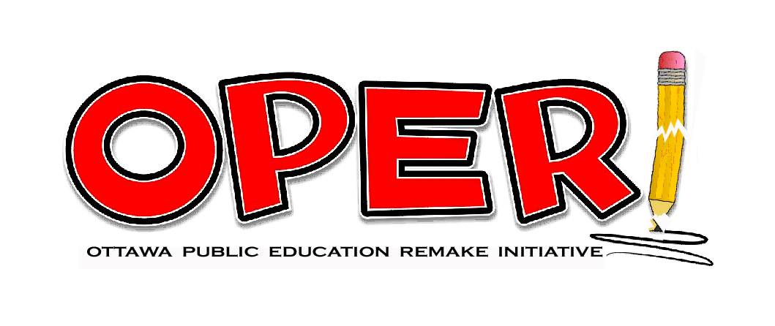
The OPERI Recap
The OPERI Recap
Vol. 2 No. 1
www.operi.ca

Living and Learning – The Hall-Dennis Report
50th Anniversary

Living and Learning, also known as The Hall-Dennis Report, published in 1968, stands out as perhaps the best government report on education ever produced. Its respect and appreciation for children is its trademark. It takes a big picture look at what they need and how to provide it equitably for all. The following is one small example of the thoughtfulness and caring that went into creating this report.

The needs of the child are simply stated. Each and every one has the right to learn, to play, to laugh, to dream, to love, to dissent, to reach upward, and to be himself. Our children need to be treated as human beings – exquisite, complex, and elegant in their diversity. They must be made to feel that the world is waiting for their sunrise, and that their education heralds the rebirth of an ‘Age of Wonder.’ Then surely, the children of tomorrow will be more flexible, more adventurous, more daring and courageous than we are, and better equipped to search for truth, each in his own way. Each will have learned, with Don Quixote, in Man of La Mancha:

To dream the impossible dream,
To fight the unbeatable foe,
To bend with unbearable sorrow,
To run where the brave dare not go.
To right the unrightable wrong,
To love, pure and chaste from afar
To try when one’s arms are too weary,
To reach the unreachable star.

The authors of Living and Learning say, “Reviews such as we have tried to make must be done again as time passes.” With calls for a new paradigm for education growing louder, and technology changing how students learn, this is a good time to return to Living and Learning. It provides a solid base upon which to adapt public education for the good of everyone.
The full text of Living and Learning can be found at: http://www.connexions.org/CxLibrary/Docs/CX5636-HallDennis.htm.

Let’s make 2018 a year to remember!
The Importance of Public Education

The greatest value of public education is its capacity to build community and a just society. It is through community schools that we can best address the equity issues discussed in the recently published Ontario’s Education Equity Action Plan. The following quote from the document gives a flavour of how the issue is being viewed.

“Systemic barriers are caused by embedded biases in policies, practices and processes, and may result in differential treatment. Barriers can be unintentional – for example, learning materials that do not take into account the diversity of our communities – often these are the result of doing things the way they have always been done. Regardless of the reason for them, their impact can be detrimental to many. It is also important for us to recognize and address the additional barriers and unique experiences of discrimination that can arise for some students when factors such as race, class, gender identity, religion and physical or intellectual ability intersect.”

Ontario’s Education Equity Action Plan: http://www.edu.gov.on.ca/eng/about/education_equity_plan_en.pdf.

Diane Ravitch is a strong supporter of public education. In this short video produced by Shoot4Education, she states why we need public education and how the dismantling of it is not in a nation’s interest. Some Canadians might want to dismiss this video as applying only to the United States. It applies equally to Canada. As people try to figure out how to transition public education to a new age, some are apt to take the competitive rather than the cooperative route. The competitive aspect is fueled with school choice, magnet schools, charter schools, vouchers and privatization. The cooperative route focuses on communities making their neighbourhood schools the best that they can be, and providing each with an equal share of national educational resources.

- Diane Ravitch website: http://dianeravitch.com/;
- The Network for Public Education: https://networkforpubliceducation.org/diane/
- Short video: https://www.facebook.com/michaelelliot.shoot4education/videos/2066161960270043/?hc_ref=ARSIC_KlNBfn9aiyShcHhVaVuhyIfffe66gYgBp_sOks4KOK9pquPaGWSe-XB9J6WU0&fref=gs&dti=1416370692001490&hc_location=group
- Shoot4Education: http://shoot4education.com/

“The society whose educational system gives priority to the economic over the spiritual and emotional needs of man defines its citizens in terms of economic units and in so doing debases them.”
- Living and Learning, p. 27
Equity Through Diversity - The Key to Remaking Public Education

The Hall-Dennis Report describes the diversity of the Canadian population back in 1968 and states, “one wonders if now is the time to think not of Canadian biculturalism but of Canadian multiculturalism.” Today’s population is even more diverse and we are learning the importance of people staying connected to their roots, of knowing from where they come.

Two events that have taken place since the previous issue of The OPERI Recap demonstrate the multicultural nature of Canada. First was the book launch of Inuit Qaujimajatuqangit in Ottawa on October 30th, 2017. It was hosted by Octopus Books and Fernwood Publishing which described the book saying,

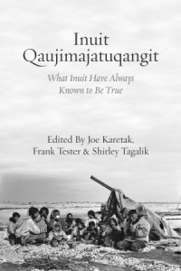
“Inuit Qaujimajatuqangit meaning all the extensive knowledge and experience passed from generation to generation — is a collection of contributions by well- known and respected Inuit Elders. The book functions as a way of preserving important knowledge and tradition, contextualizing that knowledge within Canada’s colonial legacy and providing an Inuit perspective on how we relate to each other, to other living beings and the environment.”

Nellie Taptaqut Kusugak, Commissioner of Nunavut, was one of five contributors to the book who was present for the launch.

- Fernwood Publishing: https://fernwoodpublishing.ca/book/inuit-qaujimajatuqangit
- Commissioner of Nunavut: https://www.gov.nu.ca/information/commissioner-nunavut

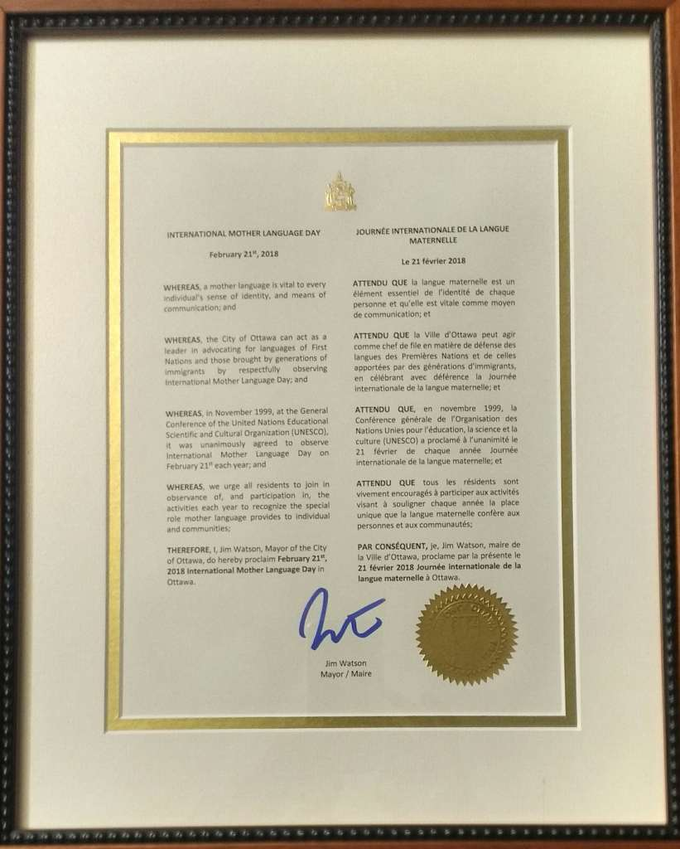
The second event took place November 15th, 2017 at the Ottawa City Hall. People gathered for Mayor Jim Watson’s proclamation of February 21st as the International Mother Language Day (IMLD) for the City of Ottawa. It was the hard work of Bangla Caravan, a community organization in collaboration with Pro-active Education for All Children’s Enrichment (PEACE) that are most responsible for the proclamation.

- The Proclamation: http://www.musitrature.com/international-mother-language-day-imld-proclaimed-city-ottawa/
- Bangla Caravan: https://www.facebook.com/BanglaCaravan/
- PEACE: http://peace-ca.com/
Proclamation of IMLD - Ottawa

“ . . . standardization removes those marks of individuality that make people persons. Standardization leads quickly and directly to depersonalization.”
- Living and Learning, p. 33

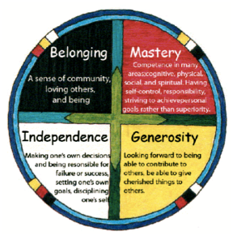
School of Cultural Creativity posted an article by the Government of Manitoba titled The Circle of Courage – Native American Model of Education. It states:
“Anthropologists have long known that Native Americans reared courageous, respectful children without using harsh coercive controls. Nevertheless, Europeans colonizing North America tried to “civilize” indigenous children in punitive boarding schools, unaware that Natives possessed a sophisticated philosophy that treated children with deep respect.”
- School of Cultural Creativity: https://www.facebook.com/schoolofculturalcreativity/posts/1969715923296365
- Poster article provided by the Government of Manitoba: http://www.edu.gov.mb.ca/k12/cur/cardev/gr9_found/courage_poster.pdf

Mental Health and Play
Linking Positive Psychology With Self-Directed Learning: A Model Of Self-Directed Wellness, by Cecilia Teal, Kellee R. Vess, and Valerie K. Ambrose. International Journal of Self-Directed Learning, 12(1), Spring 2015.

"According to the field of positive psychology, individuals flourish when they experience positive emotions, are interested or engaged in activities, and identify a purpose in or meaning to their lives (Seligman, 2011). Huppert and So (2009) assert that individuals who are flourishing also display three or more of the following attributes: positive relationships, self-determination, vitality, resilience, optimism, or self-esteem (p. 2). Seligman (2011) notes that “when individuals flourish, health, productivity, and peace follow” (p. 240)."

Article: https://docs.wixstatic.com/ugd/dfdeaf_39a44b29bcd94403b3bb2832961cb4a2.pdf
The Fragile Generation: Bad policy and paranoid parenting are making kids too safe to succeed

“As for summer frolicking, campers don't just have to take a buddy with them wherever they go, including the bathroom. Some are now required to take two—one to stay with whoever gets hurt, the other to run and get a grown-up. Walking to the john is treated like climbing Mt. Kilimanjaro.”

Article: http://reason.com/archives/2017/10/26/the-fragile-generation

The Decline of Play and Rise in Children’s Mental Disorders: There’s a reason kids are more anxious and depressed than ever

“We would like to think of history as progress, but if progress is measured in the mental health and happiness of young people, then we have been going backward at least since the early 1950s.”

Article: https://medium.com/the-mission/the-decline-of-play-and-rise-in-childrens-mental-disorders-7cc348ee8529

Outdoor Play Canada

“Outdoor Play Canada is a brand-new network of leaders and organizations working together to galvanize an outdoor play movement across Canada. We sprang from the diverse, cross-sector group that collaborated to create the 2015 Position Statement on Active Outdoor Play.

Article: https://www.outdoorplaycanada.ca/
Position Statement: http://www.haloresearch.ca/outdoorplay/

Kids need scraped knees and risky play, study says

“’The biggest risk is keeping your kids indoors’, said Dr. Mark Tremblay, the director of the Healthy Active Living and Obesity Research Group at the CHEO Research Institute who were the lead authors of a Participaction report card released Tuesday that gives Canada poor grades when it comes to the physical activity of children and youth.”

Article: http://ottawacitizen.com/news/local-news/let-your-kids-take-risks-when-they-play-study-recommends
How ‘twisted’ early childhood education has become — from a child development expert

“And never in my wildest dreams could I have imagined that we would have to defend children’s right to play.
“Play is the primary engine of human growth; it’s universal – as much as walking and talking. Play is the way children build ideas and how they make sense of their experience and feel safe.”

Article: https://www.washingtonpost.com/news/answer-sheet/wp/2015/11/24/how-twisted-early-childhood-education-has-become-from-a-child-development-expert/?utm_term=.e48c74eec897

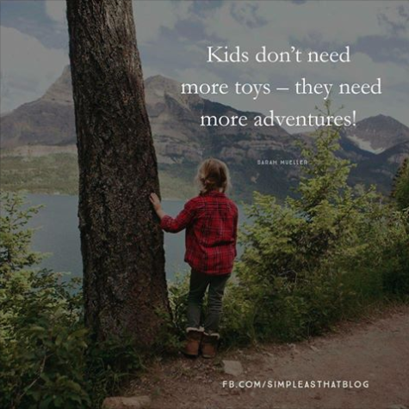
Gut health, mental wellbeing and immunity linked to outdoor play

“A disconnection from nature can affect everything in a child from gut health and immunity, to mental health and even the way they think, recent research has revealed.

Article: http://mobile.abc.net.au/news/2016-08-27/nature-play-important-for-physical-and-mental-health/7791458?pfmredir=sm
You Can’t Bounce Off the Walls If There Are No Walls: Outdoor Schools Make Kids Happier—and Smarter

“New approaches to kindergarten offer us a glimpse of what childhood used to be, and still could be—the modern re-creation of the children’s garden. If we looked to these examples, we might be able to rescue childhood.”

Article: http://www.yesmagazine.org/issues/education-uprising/the-original-kindergarten

Texas School Beats ADHD by Tripling Recess Time

“The biggest difference Rhea noticed was that students in Finland get much more recess than American kids do — 15 minutes of “unstructured outdoor play” after every 45 minutes of instruction.

Article: https://returntonow.net/2017/11/21/texas-school-beaths-adhd-tripling-recess-time/

- Play: This video features both Ken Robinson and Peter Gray.
Video: https://vimeo.com/142819446

- A Theory on Why Teen Depression and Anxiety Are Skyrocketing
Article: http://www.intellectualtakeout.org/article/theory-why-teen-depression-and-anxiety-are-skyrocketing

- 2017 Children’s Mental Health Report
Report: https://childmind.org/report/2017-childrens-mental-health-report/
Self-Directed Education

Self-Directed Education is a model receiving increasing attention as a possible replacement for the industrial model for education, which is appearing to have outlived its usefulness. The growth in democratic schools and the number of people providing unschooled learning environments for children attest to this. Most of the children experiencing the unschooled approach to learning are doing so through private options or homeschooling, but these alternatives are not available to the majority of families. Many more children would be involved in this approach to learning if it were an option for them. The challenge for public education is therefore to make Self-Directed Education available for interested parents and students.

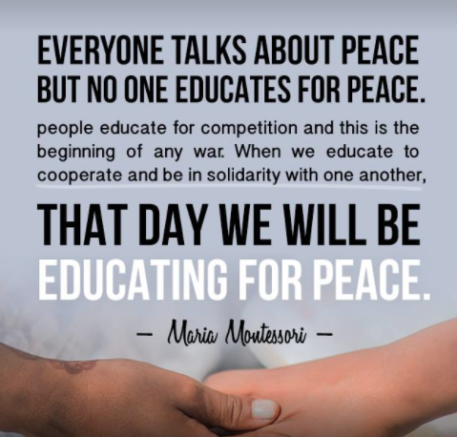
Why are Democratic Schools Growing so Quickly in France?

“I can’t imagine a pioneering enterprise happening without the full dedication of a few tireless people who think about the vision, and nothing but the vision, day and night. If they also happen to have developed strong intellectual rigor and a business mind, a school comes out of the ground. On top of this, if they happen to have strong communication skills, a whole movement emerges. If we had to sum up the source of the magic in France, it comes down to people doing what they love and showing their work, and being good at both. EUDEC France has several members who strongly display these qualities.”

Article: https://www.self-directed.org/tp/sde-growing-in-france/?platform=hootsuite
EUDEC: https://www.eudec.org/

Schooling Was for the Industrial Era, Unschooling Is for the Future

“Our current compulsory schooling model was created at the dawn of the Industrial Age. As factories replaced farm work and production moved swiftly outside of homes and into the larger marketplace, 19th century American schooling mirrored the factories that most students would ultimately join.
The bells and buzzers signaling when students could come and go, the tedium of the work, the straight lines and emphasis on conformity and compliance, the rows of young people sitting passively at desks while obeying their teachers, the teachers obeying the principal, and so on—all of this was designed for factory-style efficiency and order.”

Article: https://fee.org/articles/schooling-was-for-the-industrial-era-unschooling-is-for-the-future/?platform=hootsuite

The Joy and Sorrow of Rereading Holt’s "How Children Learn"

“My colleague Pat Farenga, who has managed Holt’s legacy ever since his death, recently oversaw the publication of the 50th anniversary edition of what to me is Holt’s most significant book, How Children Learn (Da Capo Press, 2017). I read the first edition decades ago, without full appreciation, before I had begun my own research into children’s learning. Rereading the book now led me repeatedly to think, How true, How brilliant, How sad. Sad because these true facts and brilliant insights are still understood by only a small percentage of the population, and our schools are now even worse than they were when Holt was alive. They are even more anxiety provoking, more wasteful of young people’s time, more insulting of young people's intelligence, and more disruptive of deep learning and understanding.”

Article: https://www.psychologytoday.com/blog/freedom-learn/201712/the-joy-and-sorrow-rereading-holt-s-how-children-learn

Canadian Coalition of Self Directed Learners – It includes 8 Canadian schools in three provinces.

“In its broadest meaning, ‘self-directed learning’ describes a process by which individuals take the initiative, with or without the assistance of others, in diagnosing their learning needs, formulating learning goals, identify human and material resources for learning, choosing and implement appropriate learning strategies, and evaluating learning outcomes. (M. Knowles, Principles of Androgogy, 1972)“

Website: http://ccsdl.ca/

No grades, no timetable: Berlin school turns teaching upside down

“Pupils choose their own subjects and motivate themselves, an approach some say should be rolled out across Germany.”

Article: https://www.theguardian.com/world/2016/jul/01/no-grades-no-timetable-berlin-school-turns-teaching-upside-down

How Lindsay Unified Redesigned Itself From The Ground Up

“. . . walk into any classroom and you’ll find neither students nor teachers. Instead, you’ll find “learners” and “learning facilitators.” Nobody gets an “A” or an “F” on anything, and no age-based grade levels exist. Ask a “learner” what he or she is working on and you will get dozens of different answers. But each and every learner knows exactly what they are learning, whether they have mastered it, and what comes next.”

Article: https://www.edsurge.com/news/2014-06-17-how-lindsay-unified-redesigned-itself-from-the-ground-up

Carol Black – Alternatives to Schooling - an inspiring 15 minute talk by the director of the acclaimed film Schooling the World.

A comment on Alternatives to Schooling by Lainie Liberti:
"One of the weirdest characteristics of education in our (western) society... is that our approach to education is extraordinarily authoritarian. It is *obsessed* with compulsion and control. So the child in the modern classroom may not move, speak, sing, laugh, eat, drink, read, write, think their own thoughts, look out the window, or even use the toilet without explicit permission from an authority figure.

"In WEIRD (western educated industrialized rich democratic) societies we are so habituated to this appalling lack of personal freedom that it has become functionally invisible to us and in a truly Orwellian twist, many people now consider it a 'fundamental human right' to be legally compelled to learn what somebody in authority says they have to learn."

Video Talk: https://vimeo.com/126183982
Schooling the World: http://schoolingtheworld.org/

Can a Truly Student-Centered Education Be Available to All?

A comment with this post by Mindshift:
"If some kids find success in a more open, choice-based, free environment, isn’t it worth having that option for families that want it? Perhaps the real answer is not to turn all public schools into free schools, but to allow for a bit more variety within the public system so there is something for every kind of learner."

In response to this article, Carol Black said, “There is no reason –– ZERO –– that the public system can't offer a self-directed education option to all families.”

Article: https://ww2.kqed.org/mindshift/2015/12/08/is-the-public-system-scared-to-put-students-at-the-center-of-education/

Peter Gray: Inverse Relationship Between GPA and Innovative Orientation

“The more students focus on test scores, the less creative they become.”

Article: https://www.psychologytoday.com/blog/freedom-learn/201604/inverse-relationship-between-gpa-and-innovative-orientation

Alison Gopnik’s Advice to Parents: Stop Parenting!

Peter Gray asks, “But why doesn’t she tell school authorities to stop schooling?”

Article: https://www.psychologytoday.com/blog/freedom-learn/201608/alison-gopnik-s-advice-parents-stop-parenting#_=_
#1137 Teaching Beyond Surface Behaviours

“My interest in teaching elementary school is to develop strong, confident, happy people. For me, that includes teaching traditional subjects, but more importantly, it includes developing confidence, empathy, independence, and a desire to succeed at something.”

Article: http://www.harrynowell.com/blog/2017/08/30/1137-teaching-beyond-the-surface-behaviours/
Not every child is an A grade student. Why we must not let B/C/D be shameful.

“Controversial, as I’ve been a teacher for 22 years and I’ve personally set hundreds of hours of homework in that time. But I am becoming increasingly aware of a society in which the only results that anyone wants for children, be it parental or for school statistics, are the bloody As and A*s.”

Article: http://www.halfwavinghalfdrowning.com/not-every-child-is-a-a-grade-student-why-we-must-not-let-bcd-be-shameful/

The Final Words to Hall and Dennis with Living and Learning

“With regard to multiculturalism still more questions arise; for example, what can be done consciously to prevent many children from rejecting the positive values of their emigrant homes? Do our schools succeed in making immigrant children proud or ashamed of their rich cultural heritage? Do we reap the educational benefits to be gained from the presence of the immigrant child in our classes? Next to the family, the school is the most important agency for socializing the child. In a society which draws its students from various cultural and ethnic groups, a special and exciting challenge can be found in the interacting of the youngsters. Their interaction is educative. Furthermore, not only the student body but the whole school system should profit from such multiculturalism.”
- Living and Learning, p. 30

“Our children need to acquire perspective with a sense of humor and humility. Laughter is the safety valve of most human beings. Because we are capable of laughter, we see ourselves in perspective to others and to unattainable ideals, and we appreciate the variety of routes by which we seek our goals and develop compassion for others. By learning to laugh at ourselves, to laugh at our failings and our idiosyncrasies, we learn to understand frailties and shortcomings in others.”
- Living and Learning, p. 46

